

Semester One Examination, 2017

Question/Answer booklet

MATHEMATICS

If required by your examination administrator, please place your student identification label in this box
METHODS
UNIT 3

Section Two:

Calculator-assumed

Student Number: In figures

In words

Your name

TEACHER _______________________________________

Time allowed for this section
Reading time before commencing work: ten minutes
Working time: one hundred minutes

Materials required/recommended for this section
To be provided by the supervisor
This Question/Answer booklet
Formula sheet (retained from Section One)

To be provided by the candidate
Standard items: pens (blue/black preferred), pencils (including coloured), sharpener, correction fluid/tape, eraser, ruler, highlighters

Special items: drawing instruments, templates, notes on two unfolded sheets of A4 paper, and up to three calculators approved for use in this examination

Important note to candidates
No other items may be taken into the examination room. It is your responsibility to ensure that you do not have any unauthorised material. If you have any unauthorised material with you, hand it to the supervisor before reading any further.

Structure of this paper

Section | Number of questions available | Number of questions to be answered | Working  time (minutes) | Marks available | Percentage of examination
Section One:  Calculator-free | 8 | 8 | 50 | 52 | 35
Section Two:  Calculator-assumed | 11 | 11 | 100 | 98 | 65
 |  |  |  | Total | 100

Instructions to candidates

1. The rules for the conduct of examinations are detailed in the school handbook. Sitting this examination implies that you agree to abide by these rules.

2. Write your answers in this Question/Answer booklet.

3. You must be careful to confine your response to the specific question asked and to follow any instructions that are specified to a particular question.

4. Additional working space pages at the end of this Question/Answer booklet are for planning or continuing an answer. If you use these pages, indicate at the original answer, the page number it is planned/continued on and write the question number being planned/continued on the additional working space page.

5. Show all your working clearly. Your working should be in sufficient detail to allow your answers to be checked readily and for marks to be awarded for reasoning. Incorrect answers given without supporting reasoning cannot be allocated any marks. For any question or part question worth more than two marks, valid working or justification is required to receive full marks. If you repeat any question, ensure that you cancel the answer you do not wish to have marked.

6. It is recommended that you do not use pencil, except in diagrams.

7. The Formula sheet is not to be handed in with your Question/Answer booklet.

Section Two: Calculator-assumed 65% (98 Marks)
This section has eleven (11) questions. Answer all questions. Write your answers in the spaces provided.

Working time: 100 minutes.
____________________________________________________________________________________
Question 9 (7 marks)
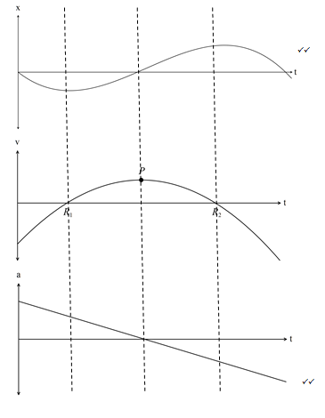
(b) The roots of occur at the same t value as the turning points on .
At , i.e. the turning point in
is a minimum.
At , i.e. the turning point in

is a maximum.

The turning point of , P, has a zero gradient so its derivative,
has a zero value at .
The gradient of is positive for and is negative for , so the

linear function is a decreasing value with an x intercept at .

Question 10 (7 marks)
The voltage between the plates of a discharging capacitor can be modelled by the function $V\left(t\right)=14e^{kt}$, where $V$ is the voltage in volts, $t$ is the time in seconds and $k$ is a constant.

It was observed that after three minutes the voltage between the plates had decreased to 0.6 volts.

(a) State the initial voltage between the plates. (1 mark)
Solution
$$V_{0}=14 \text{volts}$$

Specific behaviours
states value (units not required)

(b) Determine the value of $k$. (2 marks)
Solution
$$0.6=14e^{180k}$$
$$k=-0.0175$$

Specific behaviours
writes equation
solves, rounding to 3sf

(c) How long did it take for the initial voltage to halve? (2 marks)
Solution
$$0.5=e^{-0.0175t}$$
$$t=39.6 \text{s}$$

Specific behaviours
writes equation
solves, rounding to 3sf

(d) At what rate was the voltage decreasing at the instant it reached 8 volts? (2 marks)
Solution
$$V^{'}\left(t\right)=kV$$
$$=-0.0175×8=-0.14$$
$$\text{Decreasing at 0.14 volts/s}$$

Specific behaviours
uses rate of change
states decrease, dropping negative sign

Question 11 (7 marks)
(a) Four random variables $W$, $X$, $Y$ and $Z$ are defined below. State, with reasons, whether the distribution of the random variable is Bernoulli, binomial, uniform or none of these.
(4 marks)
The dice referred to is a cube with faces numbered with the integers 1, 2, 3, 4, 5 and 6.

(i) $W$ is the number of throws of a dice until a six is scored.
Solution
Neither - distribution is geometric

Specific behaviours
answer with reason

(ii) $X$ is the score when a dice is thrown.
Solution
Uniform - all outcomes are equally likely

Specific behaviours
answer with reason

(iii) $Y$ is the number of odd numbers showing when a dice is thrown.
Solution
Bernoulli - two complementary outcomes

Specific behaviours
answer with reason

(iv) $Z$ is the total of the scores when two dice are thrown.
Solution
Neither - distribution is triangular
Specific behaviours
answer with reason

(b) Pegs produced by a manufacturer are known to be defective with probability $p$, independently of each other. The pegs are sold in bags of $n$ for $4.95. The random variable $X$ is the number of faulty pegs in a bag.

If $E\left(X\right)=1.8$ and $Var\left(X\right)=1.728$, determine $n$ and $p$. (3 marks)
Solution
$$np=1.8, np\left(1-p\right)=1.728$$
$$∴1-p=\frac{1.728}{1.8}=0.96$$
$$p=0.04$$
$$n=\frac{1.8}{0.04}=45$$

Specific behaviours
writes equations for mean and variance
solves for $p$
solves for $n$

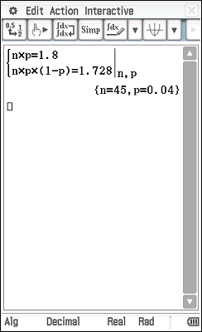

Question 12 (9 marks)
75% of the avocados produced by a farm are known to be first grade, the rest being second grade. Trays of 24 avocados are filled at random in a packing shed and sent to market.

Let the random variable $X$ be the number of first grade avocados in a single tray.

(a) Explain why $X$ is a discrete random variable, and identify its probability distribution.
(2 marks)
Solution
$X$ is a DRV as it can only take integer values from 0 to 24.
$X$ follows a binomial distribution: $X\sim B(24, 0.75)$

Specific behaviours
explanation using discrete values
identifies binomial, with parameters

(b) Calculate the mean and standard deviation of $X$. (2 marks)
Solution
$$\overline{X}=24×0.75=18$$
$$σ_{x}=\sqrt{18×0.25}=\frac{3\sqrt{2}}{2}≈2.12$$

Specific behaviours
mean, standard deviation

(c) Determine the probability that a randomly chosen tray contains

(i) 18 first grade avocados. (1 mark)
Solution
$$P\left(X=18\right)=0.1853$$

Specific behaviours
probability

(ii) more than 15 but less than 20 first grade avocados. (2 marks)
Solution
$$P\left(16≤X≤19\right)=0.6320$$

Specific behaviours
uses correct bounds
probability

(d) In a random sample of 1000 trays, how many trays are likely to have fewer first grade than second grade avocados. (2 marks)
Solution
$$P\left(X≤11\right)=0.0021$$
$$0.0021×1000≈2 \text{trays}$$

Specific behaviours
identifies upper bound and calculates probability
calculates whole number of trays

Question 113 (8 marks)
The speed, in metres per second, of a car approaching a stop sign is shown in the graph below and can be modelled by the equation $v\left(t\right)=6\left(1+\cos\left(0.25t\right)+\sin^{2}\left(0.25t\right)\right)$, where $t$ represents the time in seconds.

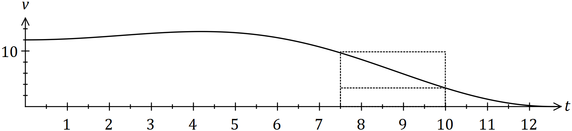

The area under the curve for any time interval represents the distance travelled by the car.

(a) Complete the table below, rounding to two decimal places. (2 marks)

$$t$$ | $$0$$ | $$2.5$$ | $$5$$ | $$7.5$$ | $$10$$
$$v(t)$$ | 12.00 | 12.92 | 13.30 | 9.66 | $$3.34$$
Solution
See table
Specific behaviours
values, rounding

(b) Complete the following table and hence estimate the distance travelled by the car during the first ten seconds by calculating the mean of the sums of the inscribed areas and the circumscribed areas, using four rectangles of width 2.5 seconds.
(The rectangles for the 7.5 to 10 second interval are shown on the graph.) (5 marks)

Interval | $$0-2.5$$ | $$2.5-5$$ | $$5-7.5$$ | $$7.5-10$$
Inscribed area | 30.0 | 32.3 | 24.15 | $$8.35$$
Circumscribed area | 32.3 | 33.25 | 33.25 | $$24.15$$
Solution
See table (may have slightly different values if using exact values of $v(t)$ rather than those from (a))
$$\sum{\text{Inscribed}}=94.8, \sum{\text{Circumscribed}}=122.95$$
$$\text{Estimate}=\frac{94.8+122.95}{2}≈108.9 \text{m}$$

Specific behaviours
values 1st col, values 2nd col, values 3rd col
sums
estimate that rounds to 109

(c) Suggest one change to the above procedure to improve the accuracy of the estimate.
(1 mark)
Solution
Use a larger number of thinner rectangles.

Specific behaviours
valid suggestion

Question 14 (10 marks)
A slot machine is programmed to operate at random, making various payouts after patrons pay $2 and press a start button. The random variable $X$ is the amount of the payout, in dollars, in one play of the machine. Each payout can be assumed to be independent of other payouts.

The probability, $P$, that the machine makes a certain payout, $x$, is shown in the table below.

Payout ($) $x$ | 0 | 1 | 2 | 5 | 10 | 20 | 50 | 100
Probability $P(X=x)$ | 0.25 | 0.45 | 0.2125 | 0.0625 | 0.0125 | 0.005 | 0.005 | 0.0025

(a) Determine the probability that

(i) in one play of the machine, a payout of more than $1 is made. (1 mark)
Solution
$$P\left(X>1\right)=1-\left(0.25+0.45\right)=0.3$$

Specific behaviours
states probability

(ii) in ten plays of the machine, it makes a payout of $5 no more than once. (2 marks)
Solution
$$Y\sim B\left(10, 0.0625\right)$$
$$P\left(Y≤1\right)=0.8741$$

Specific behaviours
indicates binomial distribution
calculates probability

(iii) in five plays of the machine, the second payout of $1 occurs on the fifth play.
(3 marks)
Solution
First payout in one of four plays:
$$W\sim B\left(4, 0.45\right)$$
$$P\left(W=1\right)=0.2995$$
Second payout:
$$P=0.2995×0.45=0.1348$$

Specific behaviours
uses first and second event
calculates $P$ for first event
calculates $P$ for both events

(b) Calculate the mean and standard deviation of $X$. (2 marks)
Solution
$$\overline{X}=1.9125, σ_{X}=6.321$$

Specific behaviours
mean
sd

(c) In the long run, what percentage of the player's money is returned to them? (2 marks)
Solution
$$\frac{1.9125}{2}×100=95.625\%$$

Specific behaviours
uses mean and payment
calculates percentage

Question 15 (6 marks)
Let the random variable $X$ be the number of vowels in a random selection of four letters from those in the word LOGARITHM, with no letter to be chosen more than once.

(a) Complete the probability distribution of $X$ below. (1 mark)

$$x$$ | $$0$$ | $$1$$ | $$2$$ | $$3$$
$$P(X=x)$$ | $$\frac{5}{42}$$ | $$\frac{10}{21}$$ | $$\frac{5}{14}$$ | $$\frac{1}{21}$$
Solution
$$1-\left(\frac{5}{42}+\frac{10}{21}+\frac{1}{21}\right)=\frac{5}{14}$$

Specific behaviours
uses sum of probabilities

(b) Show how the probability for $P(X=1)$ was calculated. (2 marks)
Solution
$$P\left(X=1\right)=\frac{\left(\begin{matrix}3 \\ 1\end{matrix}\right)×\left(\begin{matrix}6 \\ 3\end{matrix}\right)}{\left(\begin{matrix}9 \\ 4\end{matrix}\right)}=\frac{3×20}{126}=\frac{10}{21}$$

Specific behaviours
uses combinations for numerator
uses combinations for denominator and simplifies

(c) Determine $P(X≥1|X≤2)$. (2 marks)
Solution
$$P=\frac{\frac{10}{21}+\frac{5}{14}}{\frac{20}{21}}=\frac{5/6}{20/21}=\frac{7}{8}$$

Specific behaviours
obtains numerator
obtains denominator and simplifies

Let event $A$ occur when no vowels are chosen in random selection of four letters from those in the word LOGARITHM.

(d) State $P(\overline{A})$. (1 mark)
Solution
$$P\left(\overline{A}\right)=1-\frac{5}{42}=\frac{37}{42}$$

Specific behaviours
calculates probability

Question 16 (6 marks)
The base radius of a conical pile of sand is twice its height. If the volume of the sand is initially 60 $m^{3}$ and then another 1$m^{3}$ of sand is added, use the increments formula to estimate the increase in the height of pile.
Quote your result in millimetres and you should assume that that radius of the cone remains twice its height.

Solution
$V=\frac{1}{3}πr^{2}h=\frac{4}{3}πh^{3}$
When $V=60, h={(\frac{3×60}{4×π})}^{1/3}≈2.4286$
and $\frac{dV}{dh}=4πh^{2}≈4π{×2.4286}^{2}≈74.1$
$δV≈\frac{dV}{dh}δh$
Since $δV=1,$ $δh≈1/74.1≈0.0134$
So the height increases by about 13 millimetres

Marking key/mathematical behaviours | Marks
- expresses the volume as a function of height only  - evaluates $h$  - differentiates correctly and evaluates $\frac{dV}{dh}$  - uses increments formula correctly  - gives correct answer | 1  1  1+1  1  1

Question 16 (11 marks)
(11 marks)
The profit for the first few months of a company vary according to the function , where t represents months.
Hint: Use radians.

(a) FInd the first and second derivatives of the profit function and explain exactly
how these derivatives could help you graph the function. (6)
(a)

Find where = 0 to find the turning points then use to identify the types of turning points.
If < 0 then maximum turning point. If > 0 then minimum turning point.
If = 0 then you have the t value so you can find the points of inflection.

(b) Sketch the profit equation on the set of axes. (3)

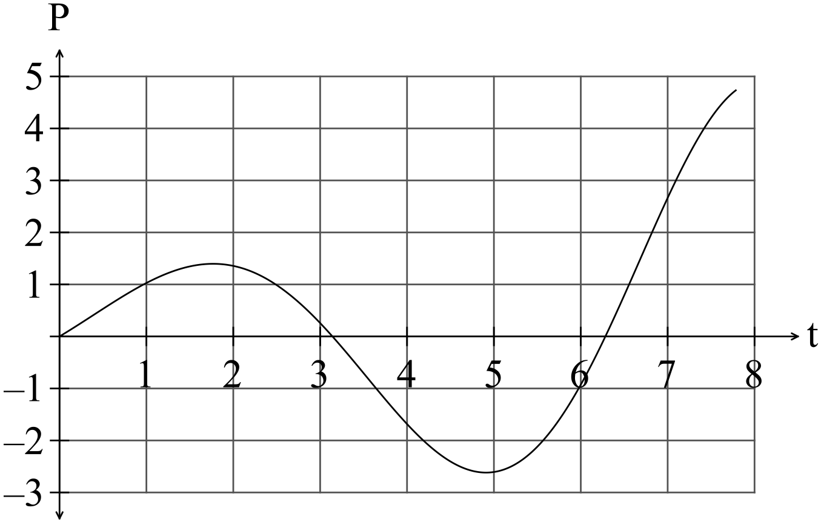 -1/error

After the first two months when the profit had been increasing, the owner employed more staff and it took a little while for sales to start to increase again.
(c) Determine when the profit started to increase again. (1
The profit started to increase again at
(d) Determine when the break even point was reached i.e. when profit again became positive. (1)
The break even point was reached at

Question 17 (6 marks)
The base radius of a conical pile of sand is twice its height. If the volume of the sand is initially 60 $m^{3}$ and then another 1$m^{3}$ of sand is added, use the increments formula to estimate the increase in the height of pile.
Quote your result in millimetres and you should assume that that radius of the cone remains twice its height.

Solution
$V=\frac{1}{3}πr^{2}h=\frac{4}{3}πh^{3}$
When $V=60, h={(\frac{3×60}{4×π})}^{1/3}≈2.4286$
and $\frac{dV}{dh}=4πh^{2}≈4π{×2.4286}^{2}≈74.1$
$δV≈\frac{dV}{dh}δh$
Since $δV=1,$ $δh≈1/74.1≈0.0134$
So the height increases by about 13 millimetres

Marking key/mathematical behaviours | Marks
- expresses the volume as a function of height only  - evaluates $h$  - differentiates correctly and evaluates $\frac{dV}{dh}$  - uses increments formula correctly  - gives correct answer | 1  1  1+1  1  1

Question 18
(5 marks)
(a)
x | 0 | 1 | 2 | 3 | 4 | 5
P(X = x) | 0.17 | 0.36 | 0.31 | 0.13 | 0.03 | 0.00

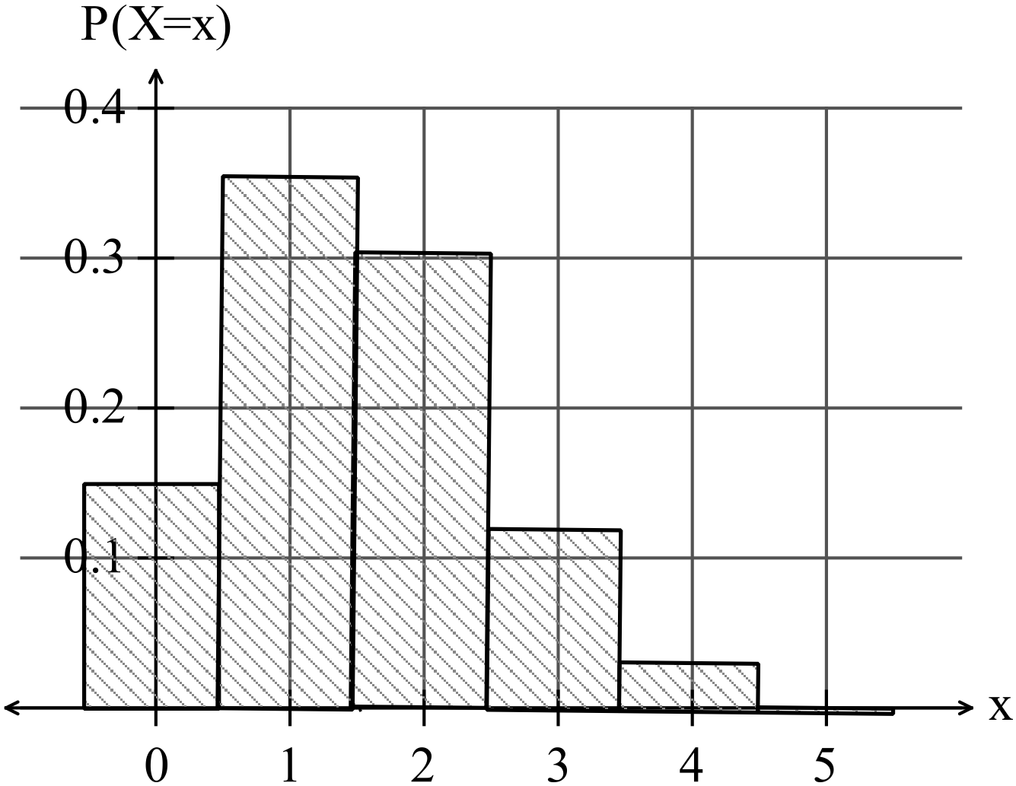
-1/error

(b) p = 0.7

Question 19 (11 marks)
The gradient function of $f$ is given by $f^{'}(x)=12x^{3}-24x^{2}$.

(a) Show that the graph of $y=f(x)$ has two stationary points. (2 marks)
Solution
$$\text{Require} f^{'}\left(x\right)=0 \\ 12x^{2}\left(x-2\right)=0 \\ x=0, x=2$$
$$\text{Hence two stationary points}$$

Specific behaviours
equates derivative to zero and factorises
shows two solutions and concludes two stationary points

(b) Determine the interval(s) for which the graph of the function is concave upward. (3 marks)
Solution
$$f^{''}\left(x\right)=36x^{2}-48x$$
$$f^{''}\left(x\right)>0⇒x<0,x>\frac{4}{3}$$

Specific behaviours
shows condition for concave upwards
uses second derivative
states intervals

(c) Given that the graph of $y=f(x)$ passes through $(1, 0)$, determine $f(x)$. (2 marks)
Solution
$$f\left(x\right)=\int{f^{'}\left(x\right)}dx=3x^{4}-8x^{3}+c$$
$$f\left(1\right)=0⇒c=5$$
$$f\left(x\right)=3x^{4}-8x^{3}+5$$

Specific behaviours
integrates $f^{'}\left(x\right)$
determines constant

(d) Sketch the graph of $y=f(x)$, indicating all key features. (4 marks)

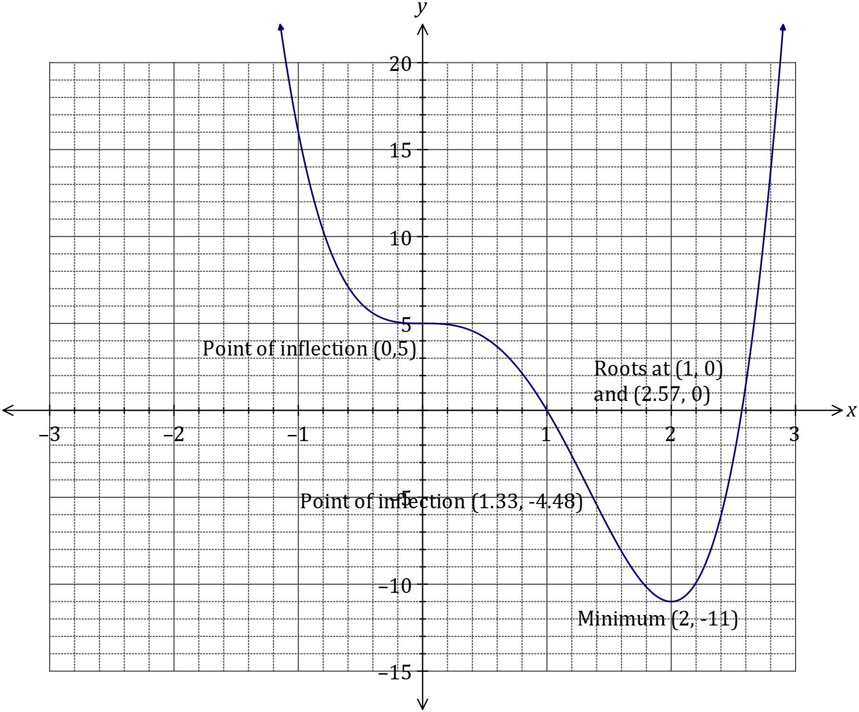

Solution
See graph
Specific behaviours
minimum
roots
points of inflection
smooth curve

Question 20 (9 marks)
(a) The area of the region bounded by the curve ,where k is a positive constant, the x-axis, and the line x = 9 is 27. Determine the value of k. (3 marks)

Solution
$$\int_{0}^{9}{kx^{\frac{1}{2}} dx = 27}$$

$$\int_{0}^{9}{kx^{\frac{1}{2}} dx = \frac{2}{3}} k\left.\sqrt{x^{3}} \right]{9 \atop 0}$$
= $18k$

$$18k=27$$
$k = \frac{3}{2}$
Marking key/mathematical behaviours | Marks
- correctly integrates  - correctly substitutes limits  - correctly solves | 1  1  1

(b) For the domain , the curves and intersect at
, and where .
(i) Determine the values of a, b and c. (3 marks)
(ii) Write down an integral to calculate the total area bounded by the two curves for the domain . (2 marks)
(iii) Evaluate the integral established in part (ii). (1 mark)
$x=a, 0 and b$
Solution
(i) a = –2.658, b = 0, c = 0.978

(ii)

(iii) Area = 2.244 square units

Marking key/mathematical behaviours | Marks
- states correct values of a, b and c for part (i)  - states correct integral for part (ii)  - correctly solves for the area in part (iii) | 3  2  1

Question 21 (5 marks)
(a)

(b)

The annual rate of growth of the population is 1.8123%
(c)
The annual rate of growth of the population is now 1.1776414% so the rate of growth of the population has slowed down considerably.

(d)

